2019

Process MyAssignment - Internal User profile creation

Solution Design Document (SDD)

Contents

1. Document Version Control 2

2. Solution Overview 3

2.1 Solution Description 3

2.2 Solution Diagram 9

2.3 Object Model Diagram 10

3. Application and Environment 11

3.1 List of Applications 11

3.2 Test and Development Environments 11

3.3 Production Environment 12

3.4 Differences between Development and Production Environments 12

3.5 Input-Output Files and Folders 12

3.6 Orchestrator Design 13

3.7 Technical Exceptions 13

3.8 Deployment 13

4. Security 13

4.1 Applications and Environment Access Model 13

4.2 Data Storage 14

4.3 Data Privacy 14

4.4 Data Preservation 14

4.5 Credentials 14

5. Operational Control and Alerting 15

5.1 Scheduling and Starting 15

5.2 Alerting 15

5.3 Automation Continuity 15

5.4 Automation Reporting and Output 15

5.5 Manual Health Check 15

6. Assumptions 16

6.1 Technical 16

6.2 Business 16

7. Technical Risks 16

8. Appendix 16

This document describes the developed automation. Its purpose is to paint a clear picture of the robot’s functionalities and design without having to view the code. This enables a smooth handover between development and maintenance.

1. Document Version Control

|  |  |  |  |
| --- | --- | --- | --- |
| Date | Revision | Author | Description |
| 11/6/2019 | V1.0 | Amit Singh | Internal User access to MyAssignment after business approval |
| 15/6/2019 | V1.1 | Amit Singh | Added JIRA process flow |
| 26/6/2019 | V2.0 | Amit Singh | SDD sign off changes |

1. Solution Overview

2.1 Solution Description

This document describes the overall design for the robotic process that will automate the “**Internal User access in MyAssignment**” after business approval.BOT will check the role requested and will create the access in the system.

Also, To add access in questionnaire for new user in JIRA.

Steps to be followed by BOT

1. Launch the BMC Remedy ITSM (**http://supporteu.capgemini.com/**) and Login using the Non-SSO credentials stored in Orchestrator Assets

Below screen will appear post login.

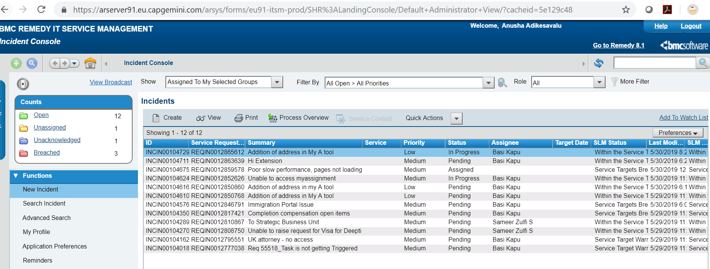

Extract the incidents data and check column “Operation Categorization Tier 3” for value “Internal User Profile Creation”.

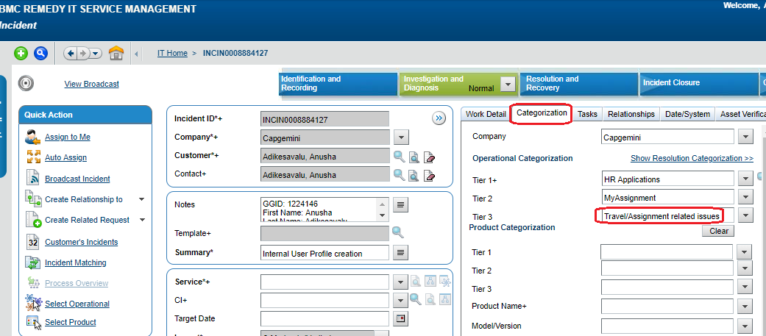

BOT will open “Notes” by clicking on below highlighted view button and will fetch the mandatory details:

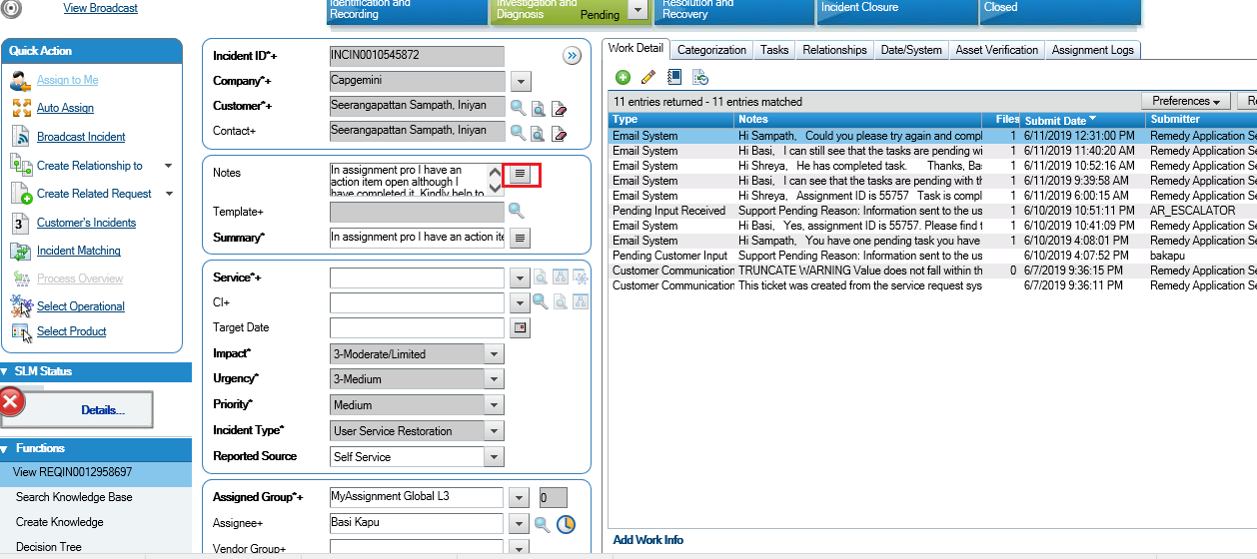

Note: For MT3 – Internal profile Creation, there is no validation team. There will be an approver to whom the tickets will be routed for approval once the request is raised by the user. The person raising the ticket via remedy form, has to take care of these details in right format.

1. If below mentioned details are not present or missing, then BOT will send an email to **DL IN MyAssignmenttechsupport** <myassignmenttechsupport.in@capgemini.com> with incorrect /missing details and **will assign** the ITSM ticket to **MyAssignment Global L3**.

|  |  |  |
| --- | --- | --- |
| GGID |  |  |
| First Name |  |  |
| Last Name |  |  |
| Email ID |  |  |
| Role (Checkbox) | 1. Administrator |  |
|  | 2. Administrator Read Only |  |
|  | 3. Queue Manager |  |
|  | 4. IAS Internal user (Checkbox under the role IAS Internal User) |  |
|  | a. Assignment Coordinator |  |
|  | b. Compensation & Benefits Coordinator |  |
|  | c. Evidence Request Coordinator |  |
|  | d. Immigration Case Worker |  |
|  | e. Immigration Case Reviewer |  |
|  | f. Immigration Case Manager |  |
|  | g. Labor Condition Reviewer |  |
|  | h. Onsite IAS Coordinator |  |
|  | i. Visa Stamping |  |

1. BOT will login as using the credentials fetched from Orchestrator Asset in **APRO** through below link

Non SSO Link

<https://capgemini.assignmentpro.com/Main/OtherPages/SignIn.aspx>

**3.1. Validation: (Checks if user profile already exists)**

Click on the below link to validate users:

**Test** instance link -

<https://testcapgemini.assignmentpro.com/Security/UserMaintenance/Users.aspx>

**Prod** instance link -

<https://capgemini.assignmentpro.com/Security/UserMaintenance/Users.aspx>

Go to **Configuration 🡪 User Maintenance** Select the User Type as **‘Internal’** and enter the **Email** and click on Search button

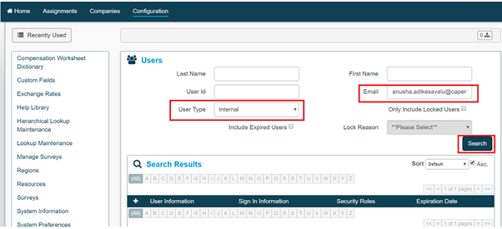

Check if the profile exists with same **security role** and with **blank** Expiration date.

1. If **YES**, there is no need to create any new profile and send an email as per above Step no. 2
2. If **NO**, proceed creating a new profile (step no. 3.2 onwards…)
   1. **Profile Creation: (User profile, Resource profile)**

Below is the template to be used for reference purpose as per the user profile role



* + 1. **User Profile creation**

BOT will browse the below link to create a **new User profile** (**Configuration 🡪 User Maintenance, click on + sign to create new one**)

**Test** instance link -

[https://testcapgemini.assignmentpro.com/](https://testcapgemini.assignmentpro.com/Security/UserMaintenance/Users.aspx)[Security/UserMaintenance/UserMaintenance.aspx?UserID=0](https://capgemini.assignmentpro.com/Security/UserMaintenance/UserMaintenance.aspx?UserID=0)

**Prod** instance link -

<https://capgemini.assignmentpro.com/Security/UserMaintenance/UserMaintenance.aspx?UserID=0>

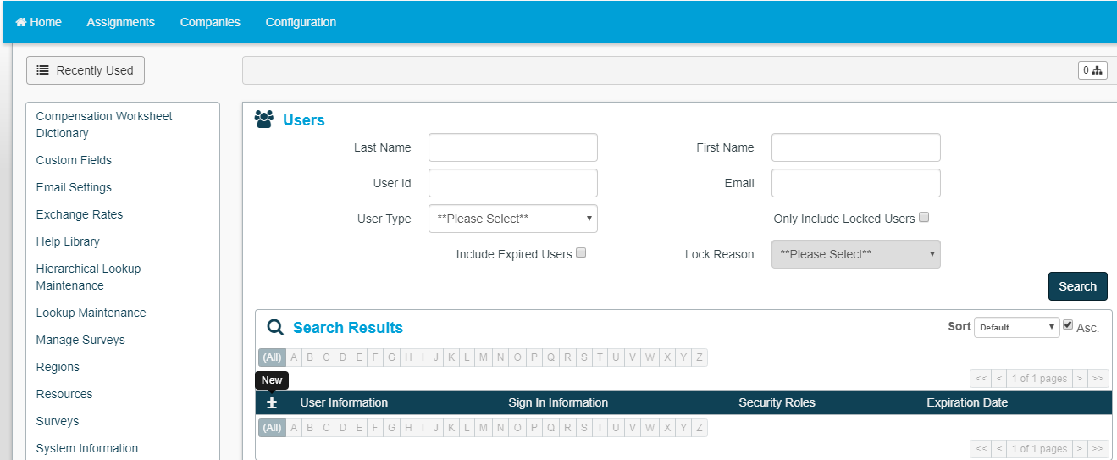

‘+’ sign will take you to user profile creation

Data getting entered as below. Fields will differ based on the roles requested.

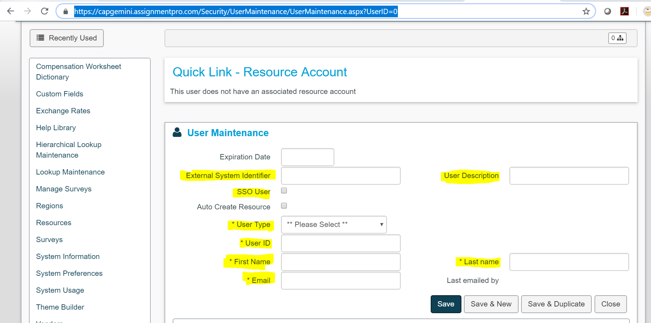

Once the highlighted fields have been filled, go to below screen and select

the requested role and click “**Save**”

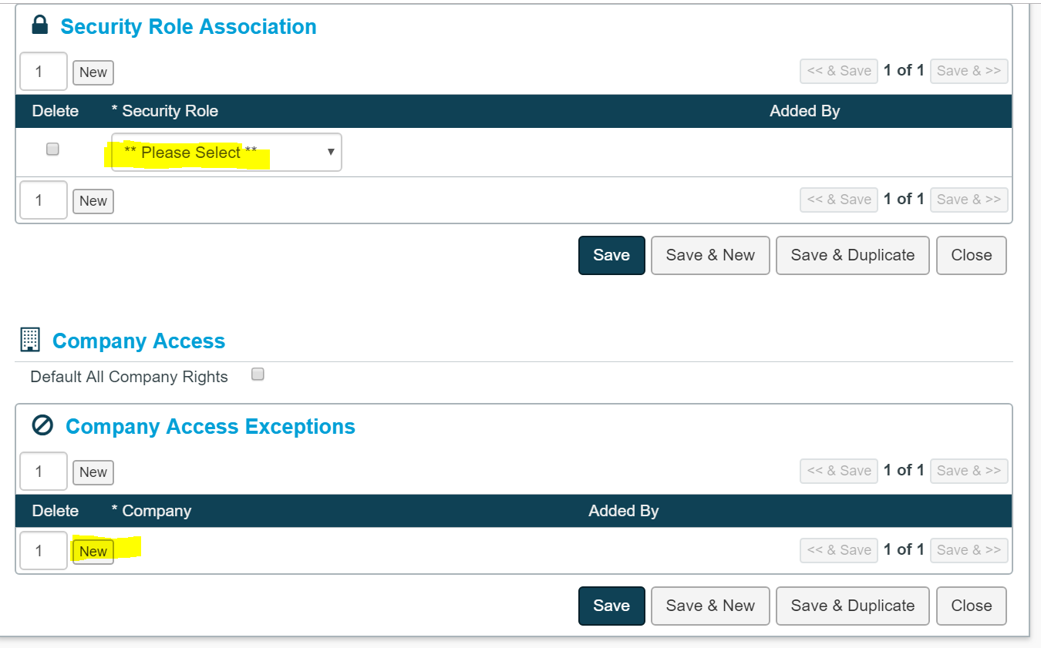

Click on **Generate Password** Button after **saving** the data under User Profile

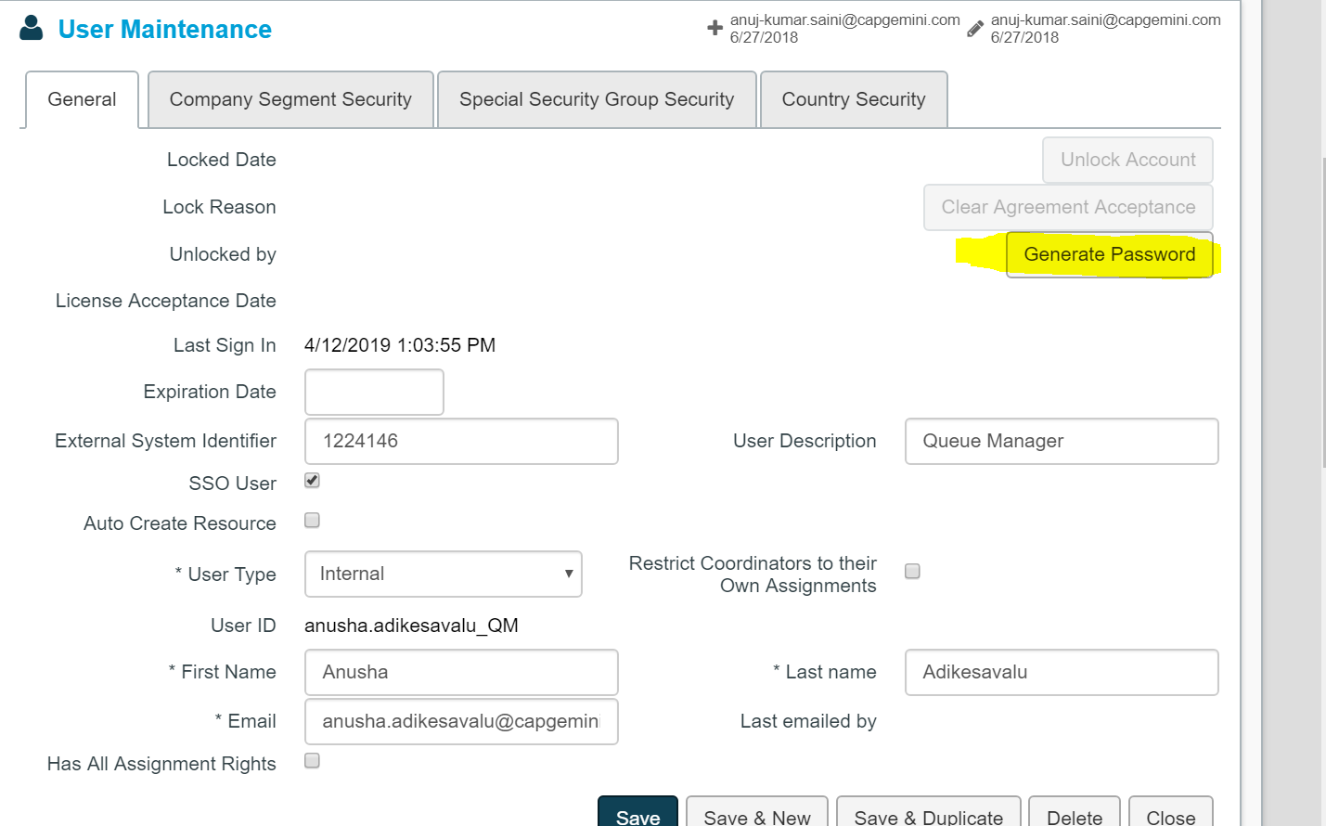

* + 1. **Resource Profile creation**

After creation of User profile, need to fill details (as per excel sheet attached) for Resource Profile creation using below link

**Test** instance link -

<https://testcapgemini.assignmentpro.com/Main/Resource/ResourceDetails.aspx>

?ResourceID=0

**Prod** instance link -

[https://capgemini.assignmentpro.com/Main/Resource/ResourceDetails.aspx? ResourceID=0](https://capgemini.assignmentpro.com/Main/Resource/ResourceDetails.aspx?%20ResourceID=0)

Snapshots are as below

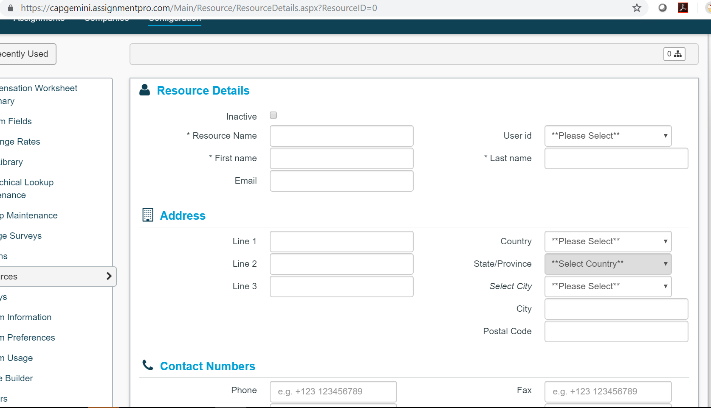

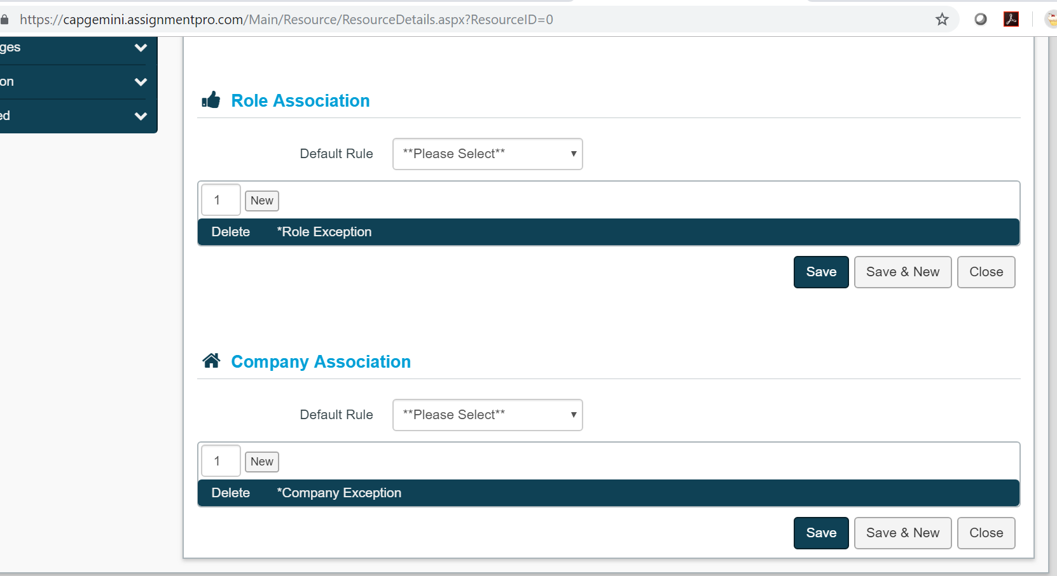

1. BOT will raise request in JIRA to add the user access (except Queue Manager) in questionnaire as below:

Steps to raise the JIRA:

Access below link (Equus need provide you the access to JIRA to access below link).

[JIRA](https://equusoft.atlassian.net/browse/CAP-2362)

Or

https://equusoft.atlassian.net/browse/CAP-2362

Click on the ‘+’ symbol as highlighted in below screen.

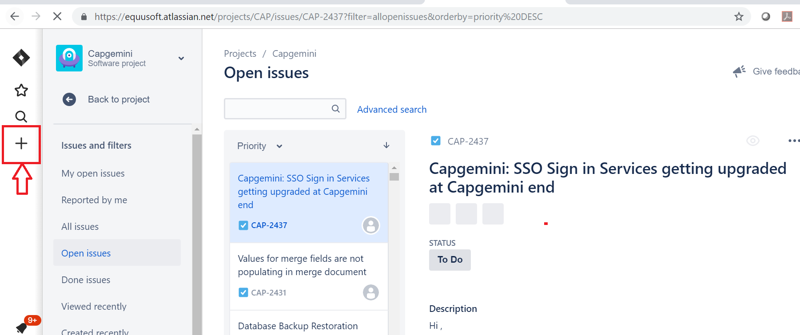

Below screen will appear. Fill the details in the highlighted fields as shown in below screen

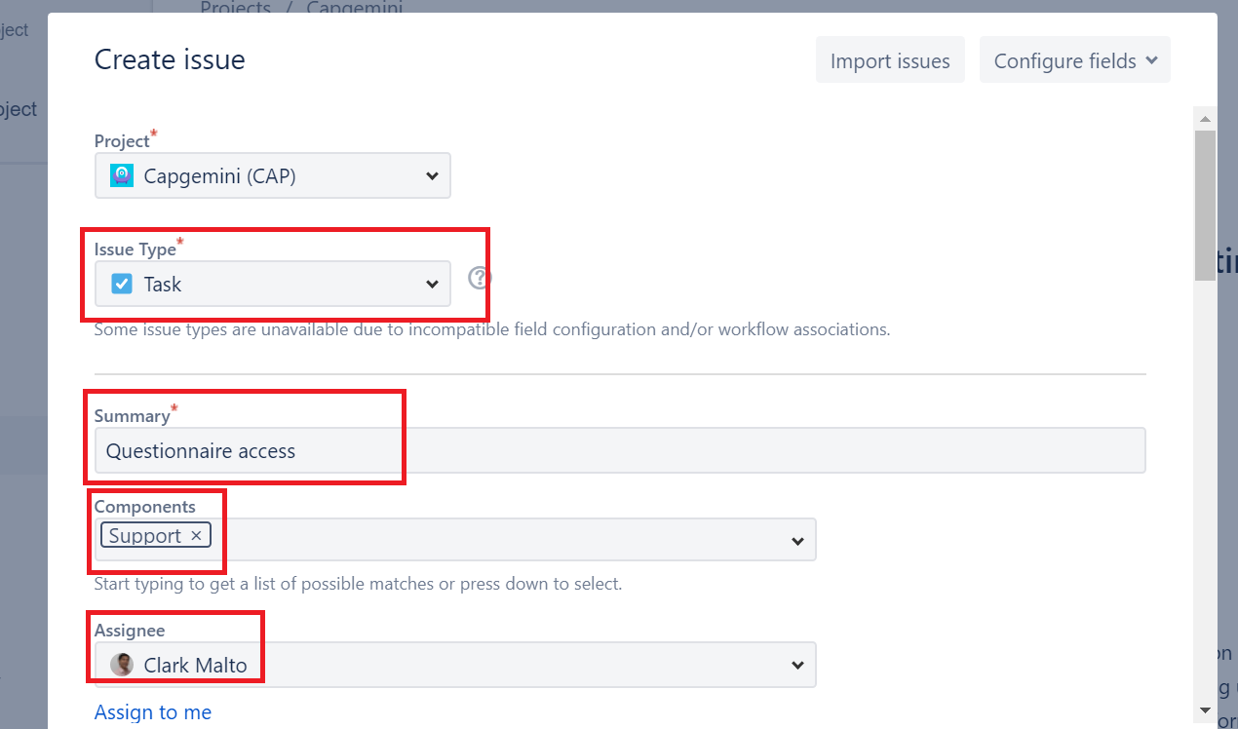

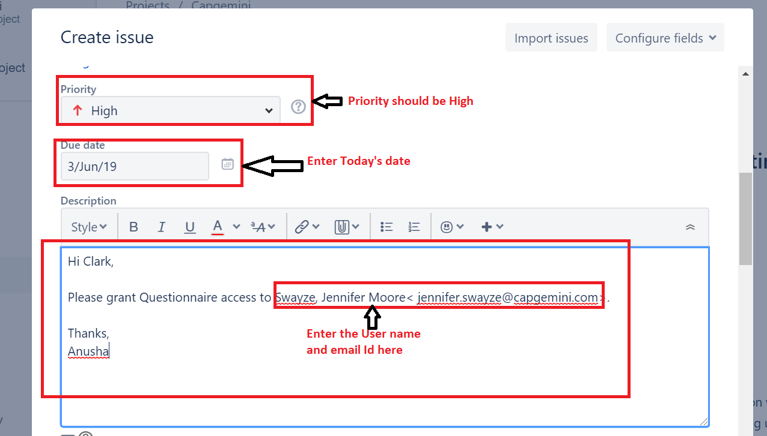

Select the work type as **Support** work and click on ‘**Create’**

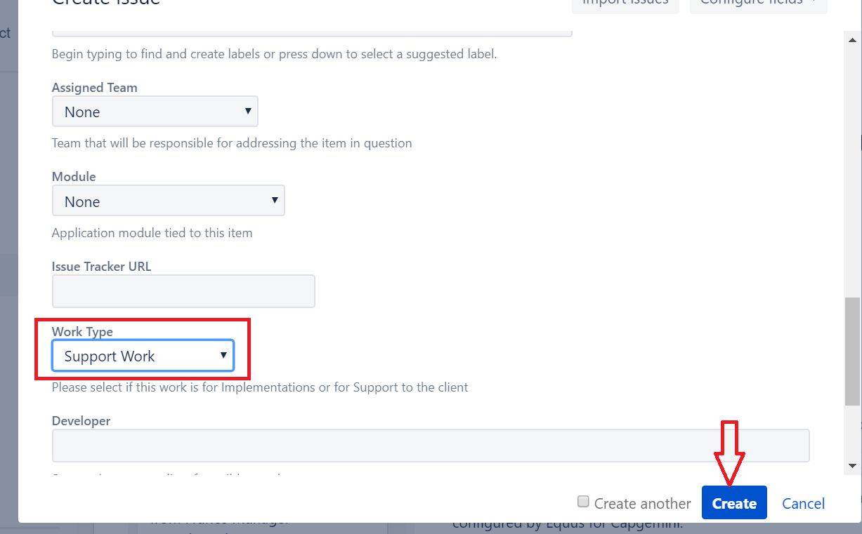

Note: Further Jira steps will not be covered in this Bot Creation.

1. Once the above steps are being performed then BOT will close the ITSM as per below steps.
   1. BOT will select the ‘Categorization’ tab from incident & will click on ‘Show Resolution Categorization' as highlighted in below screenshot

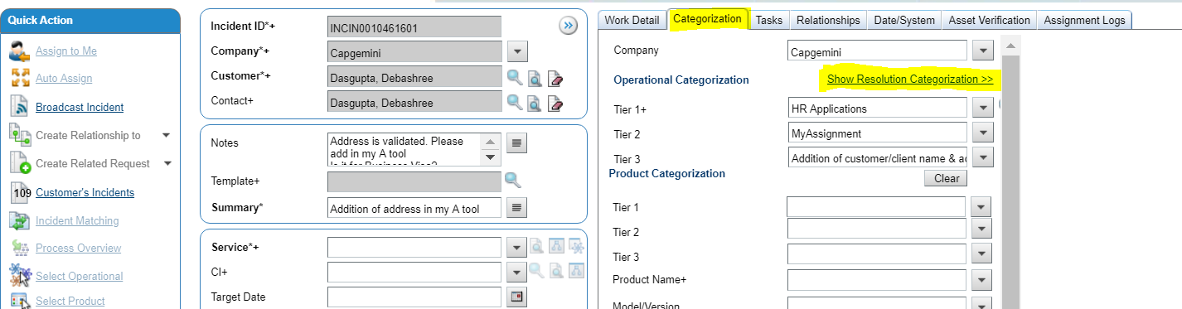

* 1. Browse to “Resolution Categorization” tab

Select “Updated” Value in “Tier 1” field and “Data” value in “Cause” field as shown in below screen.

Select value as “Resolved” in “Status” field, “Status Reason” as “Resolved by providing workaround”

Enter “User profile has been created in the MyAssignment system” value in “Resolution” field

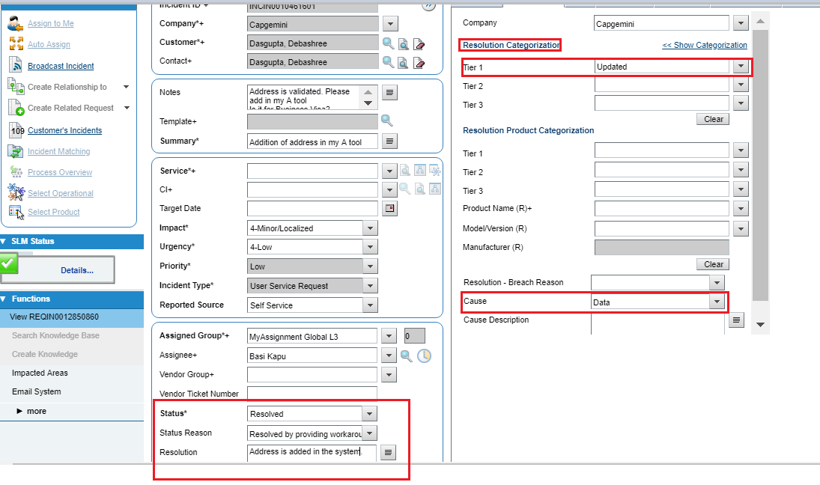

Click on **save** button after filling the above highlighted fields

Below is the final version of URS with detailed description of process. (URS name only)

|  |  |
| --- | --- |
| Sr. No. | URS Description |
| **1** | MT3.RPA URS - InternalUserCreation_v4.0 |

2.2 Solution Diagram

High Level Process flow chart:

2.3 Object Model Diagram

Following diagram shows the high-level organization of reusable Library components.

* UiPath RE-framework Library: Reusable standard library components provided by UiPath

as a part of RE-Framework.

* MyAssignment Library: Modules implementing the MyAssignment specific functions.
* ITSM Library: Modules implementing ITSM specific activities for ticket operations.

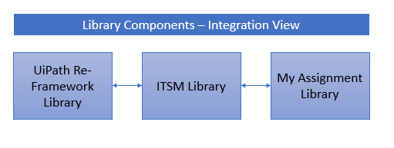

Following table lists the XAML files for the UiPath modules that are part of the overall design:

|  |  |  |
| --- | --- | --- |
| Name | Description | Generic / Specific |
| InitAllSettings.xaml | Configurations is read from the config file | RE Framework Generic File |
| InitAllApplications.xaml | Invoke OpenMyAssignment.xaml to launch MyAssigment Application  Invoke OpenITSM.xaml to launch ITSM Application | RE Framework Generic File |
| OpenITSM.xaml | Login to ITSM & navigate to “Assign to Me” group queue | Generic |
| OpenMyAssignment.xaml | Launch MyAssignment Application and Login | Generic |
| GetTransactionData.xaml | Invoke GetTaskDetails.xaml to fetches transactional data from ITSM | RE Framework Generic File |
| ProcessTransactionData.xaml | Invoke to do all the user profile creation step in MA | Generic |
| Process.xaml | Process MyAssignment details fetched from ITSM | RE Framework Generic File |
| CloseAllApplications.xaml | Close MyAssignment & ITSM | RE Framework Generic File |
| KillAllProcesses.xaml | Kills all IE process | RE Framework Generic File |
| CloseITSM.xaml | Close ITSM ticket | Generic |
| Logging.xaml | Creates log file at C:\RPA Files\Log | Generic |
| SendEmail.xaml | Send email to group IT team for notification | Generic |
| OutputScreenshot.xaml | Take Screenshot of output & save into output folder | Specific |
|  |  |  |

3. Application and Environment

This chapter lists relevant business applications start up paths and parameters, and other relevant folders and network paths.

* 1. List of Applications

Following are the applications that participate in the process execution:

* MyAssignment
* ITSM
  1. Test and Development Environments

|  |  |
| --- | --- |
| Application Name: | MyAssignment |
| Path (Development & Testing): | <https://TestCapgemini.assignmentpro.com> |
| Access details (Development): | This is the Test MyAssignment URL. |

|  |  |
| --- | --- |
| Application Name: | ITSM remedy |
| Path (Development & Testing): | <http://gditmutwswv51p.corp.capgemini.com:8080/arsys/shared/login.jsp> |
| Access details (Development): | This is the Test ITSM remedy URL. |

* 1. Production Environment

|  |  |
| --- | --- |
| Application Name: | MyAssignment |
| Path (Development & Testing): | https://capgemini.assignmentpro.com/ |
| Access details (Development): | This is the Live MyAssignment URL. |

|  |  |
| --- | --- |
| Application Name: | ITSM |
| System Name (Dev): | http://supporteu.capgemini.com/ |
| Access details (Development): | This is live ITSM URL |

|  |  |
| --- | --- |
| Application Name: | JIRA |
| System Name (Dev): | <https://id.atlassian.com/login?continue=https%3A%2F%2Fequusoft.atlassian.net%2Flogin%3FredirectCount%3D1&application=jira> |
| Access details (Development): | This is JIRA production URL |

* 1. Input-Output Files and Folders

|  |  |
| --- | --- |
| **Folder Name** | **Description** |
| MT3-InternalUserProfileCreation\Data | Configuration file that is created by the RE Framework and will be added with additional configurations. |
| MT3-InternalUserProfileCreation\Documentation | RE Framework documentation. |
| MT3-InternalUserProfileCreation\Framework | RE Framework generated XAML files. |
| MT3-InternalUserProfileCreation\Project | UiPath scripts and other files created as part of the development. |

* 1. Orchestrator Design

NA

* 1. Technical Exceptions

Following table lists the possible technical exceptions and how the process will handle them:

|  |  |
| --- | --- |
| Exception | Handling the exception |
| MyAssignment Unavailable | If MyAssignment login fails, bot will send an email to “DL IN MyAssignmenttechsupport <[myassignmenttechsupport.in@capgemini.com](mailto:myassignmenttechsupport.in@capgemini.com)>” and stop the process. |
| ITSM Unavailable | If ITSM login fails, bot will send an email to “DL IN MyAssignmenttechsupport <[myassignmenttechsupport.in@capgemini.com](mailto:myassignmenttechsupport.in@capgemini.com)>” and stop the process. |
| Configuration file is missing or not accessible | Log the exception, bot will send an email to “DL IN MyAssignmenttechsupport <[myassignmenttechsupport.in@capgemini.com](mailto:myassignmenttechsupport.in@capgemini.com)>” and stop the process. |

Business Exception:

|  |  |
| --- | --- |
| Client addition mandatory data | If user has not provided all mandatory data in ITSM, bot will send an email to “DL IN MyAssignmenttechsupport <[myassignmenttechsupport.in@capgemini.com](mailto:myassignmenttechsupport.in@capgemini.com)>” and stop the process. |

* 1. Deployment

The Bot will be deployed onto a server within Capgemini AWS environment.

1. .Security
2. 1. Applications and Environment Access Model

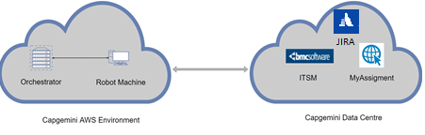

* 1. Data Storage

The process works with the data stored in the ITSM and MyAssignment Portal. The process will not store any data outside these two applications except the execution logs and the exception details.

* 1. Data Privacy

There is no data stored within the automation process.

* 1. Data Preservation

NA

* 1. Credentials

Credentials will be picked from Orchestrator Asset.

1. . Operational Control and Alerting
   1. Scheduling and Starting

TBD

* 1. Alerting

The process will be monitored through Orchestrator and if any issue occurs notification will be sent through email.

* 1. Automation Continuity

As per the requirements provided by Group IT team, when an application specific exception occurs, it will be handled by sending mail to the configured Email ID.

* 1. Automation Reporting and Output

Process will be taking snapshot of successful completion and will be sending email to configured email address.

* 1. Manual Health Check

Logs will be created for every significant action taken and will be stored on the common location. Logs will be having below mentioned details.

* Epic Name
* Process Name
* Priority
* Transaction Id
* Host Name
* Log Datetime
* User Id
* Message- a multi field value stored as JSON String
* Entry Type (from UiPath activity- information, warning etc.)

1. .Assumptions
   1. Technical

Below are the Technical assumptions:

* Service Accounts provided for the MyAssignment and ITSM will have all the necessary privileges.
* Production and Development will have similar look and feel. If there is any such case where look & feel constraints present, it will be treated against Change Request.
* All the pre-requisite software (MS Outlook) will be available on the development and production servers.
* Required email account will be configured on the development and production servers.
* The response time of the process will be limited by the response provided by the MyAssignment and ITSM applications
* Bot will be deployed on Capgemini AWS Platform which will be connected to Capgemini Data Centre for data Inputs.
  1. Business

NA

1. .Technical Risks

If the process stops working, Orchestrator will retry it twice. If it still does not work, it will send an email to configured email address. This will have a business impact.

Group IT team will have to manually process this.

1. .Appendix

NA